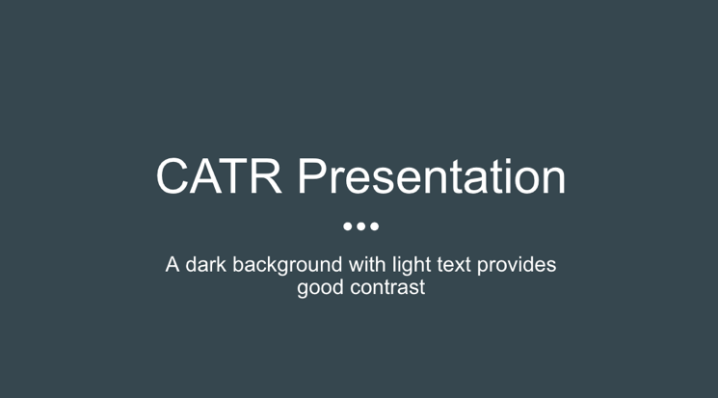
PowerPoint/Google Slides
- Choose a presentation theme with high contrast
  - Dark background with light text, or light background with dark text
  - Avoid putting red and green or blue and yellow together as these colours are less distinct for people who are colour-blind

- Use a sans serif font (noted to be the most accessible font type)
  - Examples: Arial, Calibri, Helvetica, Tahoma, and Verdana

- Avoid flashy transitions or animations in your presentation

- Avoid putting block quotes on your slides as they can be challenging to read. Rather, you can have the full block quote included in your access paper. Check out the sample access paper below for more info!

Visual Descriptions
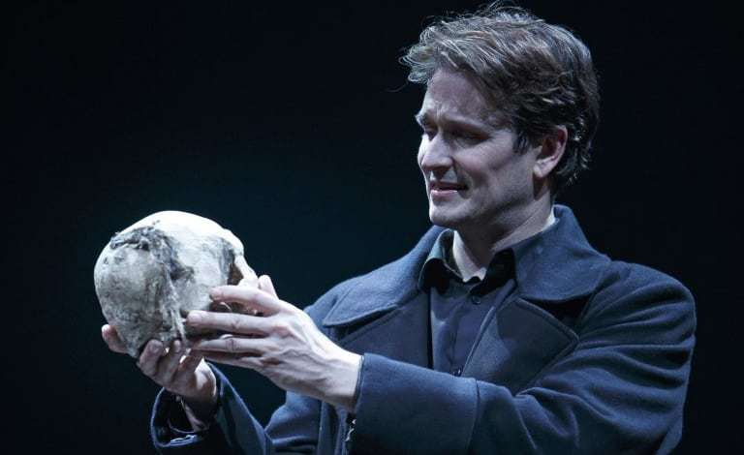
Images
- Visual descriptions give audiences who are blind or have low-vision a sense of what visual information is being presented. These descriptions do not have to be overly detailed.

- Example: This photo is from Stratford’s 2015 production of Hamlet starring Jonathan Goad. The photo shows Goad, a white man in his early 40s with short brown hair, dressed in a dark blue jacket. He is mid-speech, cradling a skull in both hands.

- The description provides the audience with a general sense of what the actor looks like, as well as what he is wearing and doing on stage.

Video Clips
- Rather than attempting to describe the video as it is playing, it can be more effective to offer a brief visual introduction.

- Example: In this clip Amaka Umeh, a Black actor with short dreadlocks, runs onto the Stratford Festival stage. She wears a grey blazer and a blue medical mask. She stands next to a ghost light before removing her mask and delivering Hamlet’s soliloquy.
- Link to video referenced: https://www.cbc.ca/arts/watch-amaka-umeh-the-first-black-woman-to-play-hamlet-at-stratford-perform-its-most-iconic-scene-1.5697719

Sharing Your Access Paper
Online Presentations
- If presenting online, please share your access paper in the Zoom chat at the start of your presentation.
- We recommend sharing as a “view-only” Google doc, but feel free to share in another online format if that works better for you.
NB: Please avoid sharing as a PDF as they can sometimes be difficult for screen readers.
- For more information about how to create and share a “view-only” Google doc, please refer to the “How to Share Your Online Access Paper” document.

In-Person Presentations
- Please bring at least 2-3 physical copies of your access paper to your in-person session.
- If you do not have access to a printer, you can email your access paper to: catracrtsubmit@gmail.com up until 8:00 AM (ADT) the morning of your presentation. A conference assistant will be happy to print off your access copies and bring them to your session.

Heading indicates that this is an access copy

SAMPLE ACCESS PAPER
Title of the presentation is bolded, presenter’s name is clearly indicated
Becky Gold

This is a sample access paper. Access papers are beneficial for several reasons – they help people experiencing your presentation to follow along visually, and also assist accessibility providers (live transcribers/captioners or ASL interpreters) in being as accurate as possible in their work. In acknowledging concerns about intellectual property/works in progress, access papers are only meant to be available for the duration of the presentation and are to be handed back to the presenter at the end of their session. In a digital context, access papers will be made available for a limited time only.
The text is in a larger (size 14) sans serif font (Calibri) and is double spaced. Other accessible fonts include Arial, Tahoma, Verdana, and Helvetica

Typically, an access paper would be a version of the paper that you will be reading for your presentation, with a few adjustments made to the format – these have been highlighted in yellow text boxes. If you are not reading a paper, you could instead provide an outline with any direct quotes that you will be citing. An access paper also offers panel attendees the opportunity to read along at their own pace. This can assist with comprehension of the content that you are presenting. If you are including a lengthy quote as part of your presentation, having it written out in your access paper makes it much easier to read than putting it up on a slide to be read from a distance. For example, if we were discussing Hamlet and you wanted to include a large excerpt, you could include it in your access paper like this:
Numbering pages can be helpful for those with hard copies to ensure their access copy stays in order
In Hamlet’s famous ‘To Be or not To Be’ soliloquy, he speaks the following:
To be, or not to be: that is the question:
Whether ’tis nobler in the mind to suffer
The slings and arrows of outrageous fortune
Full block quote is indented and includes a citation
Or to take arms against a sea of troubles,
And by opposing end them? To die: to sleep;
No more; and by a sleep to say we end
The heart-ache and the thousand natural shocks
That flesh is heir to, ’tis a consummation
Devoutly to be wish’d. To die, to sleep;
To sleep: perchance to dream: ay, there’s the rub; (Act III, Scene i)

Finally, including a works cited can be helpful for attendees to connect the content presented to the scholarship cited as well as for interpreters/captioners to double check the spelling of any names that they may not be familiar with.
Providing an access paper is one of a few simple things that you can do to enhance the accessibility of your conference presentation. If you have any questions or require further support on creating an accessible copy of your paper, please reach out to the accessibility committee at catr.accessibility@gmail.com and we will be more than happy to assist!

