Saving and Sharing Your Access Paper as a “View-Only” Google Doc:

Instructions: For online presentations, we recommend that presenters save their access papers as “view-only” Google docs and share in the Zoom chat at the start of their presentation.

If you would like some help saving your access paper as a Google doc, don’t have access to Google docs, or encounter any technical difficulties while creating your access paper, please don’t hesitate to reach out to Jayna Mees (Co-Chair, Accessibility Committee) via email at: catr.accessibility@gmail.com and she will be happy to assist you!

There are several ways to save your access paper as a “View-only” Google doc. Here are 3 methods that you can try:

Option 1

- Start by opening Google Drive in your Google apps:
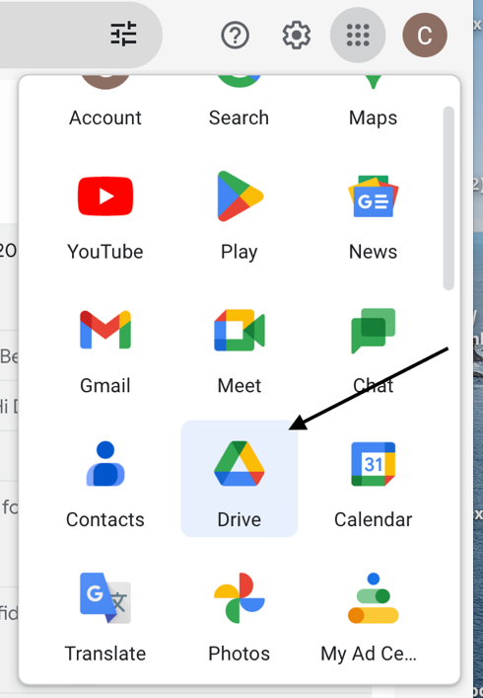

- Once you’ve opened Google Drive, go to the top-left menu bar, and click the “+ NEW” button.
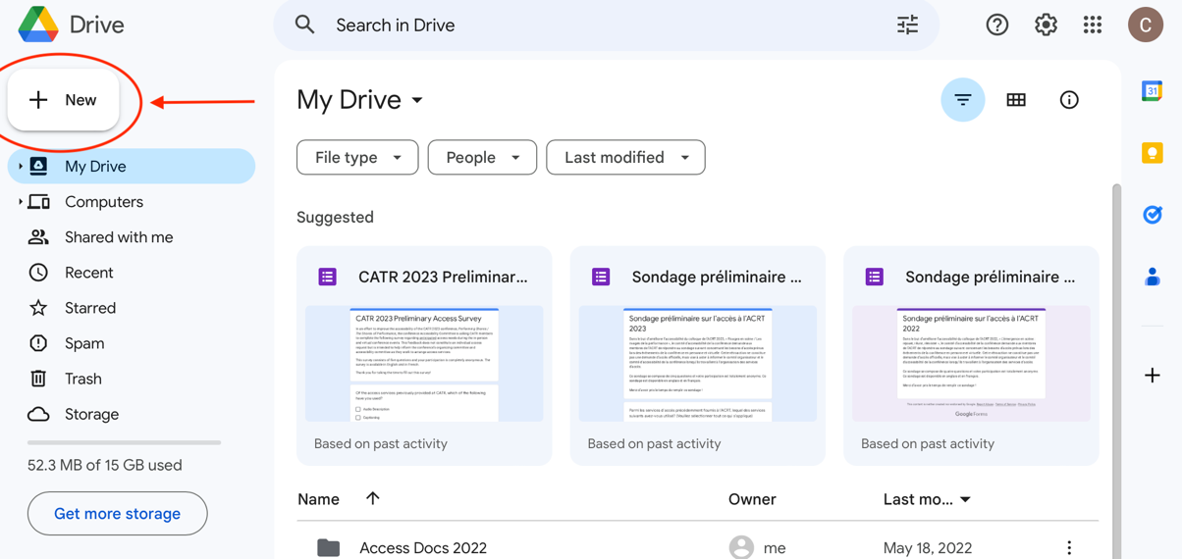

- This will bring up a drop-down menu that looks like this. Click on “New folder.”

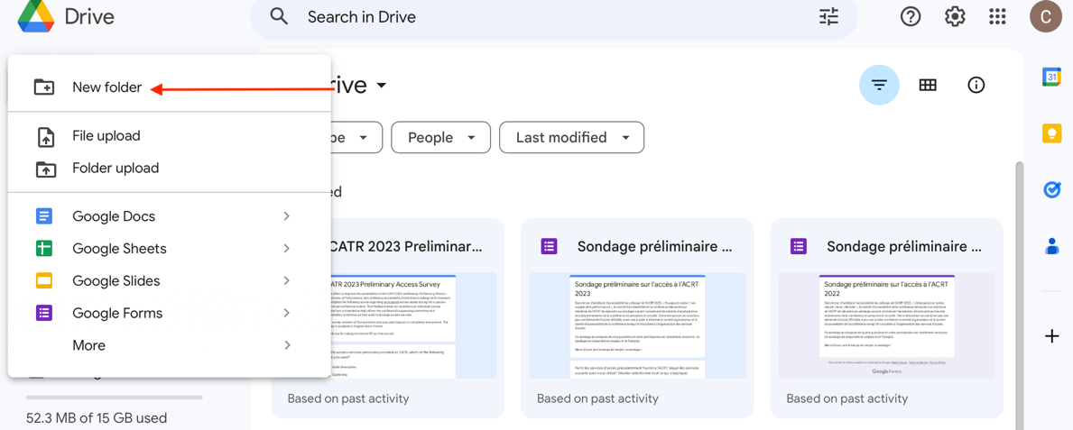

- Title your new folder and click “create.”

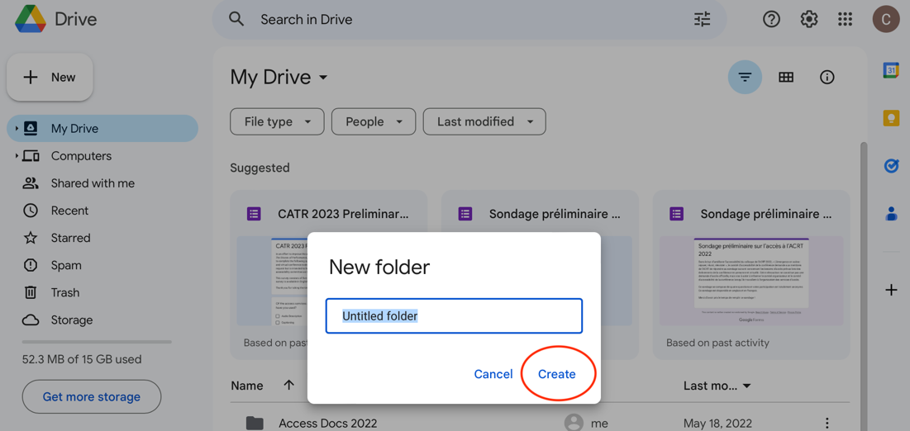

- Your new folder will appear in your list of folders (N.B. Your folders are automatically listed alphabetically). Open your new folder by double-clicking it:

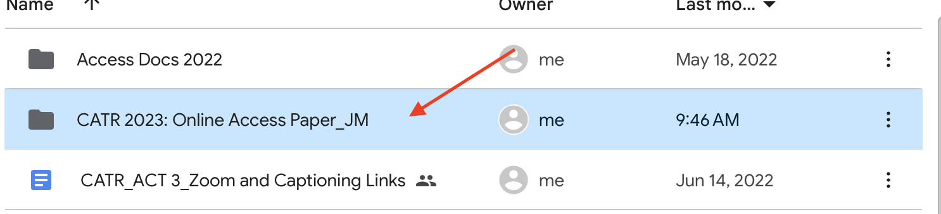

- Drag and drop your access paper from your desktop into your new Google folder. Once your access paper has finished uploading, double-click to open and verify that your access paper is:
- Using a sans serif font (Arial, Calibri, Helvetica, Tahoma, Verdana)
- Using font size 14-16
- And that the spacing + overall layout of your document has remained the same (sometimes when transferring from an outside app or outside software like Word to Google docs, the spacing/layout can shift slightly).

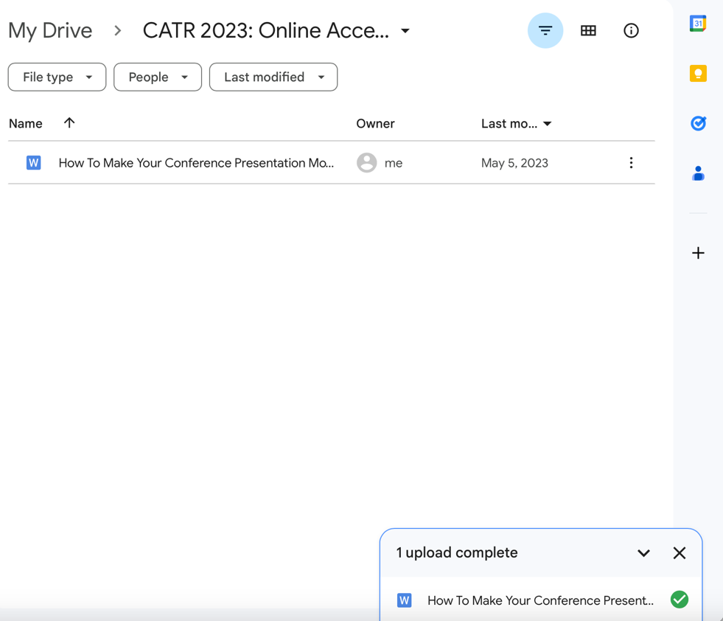

- Once you’ve verified the layout of your access paper, click on the 3 vertical dots (more actions button) located on the right side of your file. This will bring up a new drop-down menu. Click on “Share.”
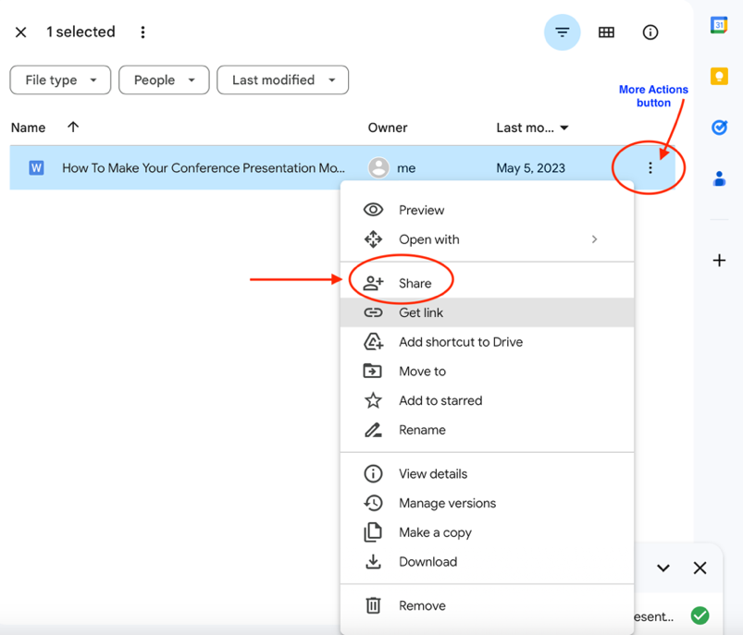

- This will bring up the following menu:

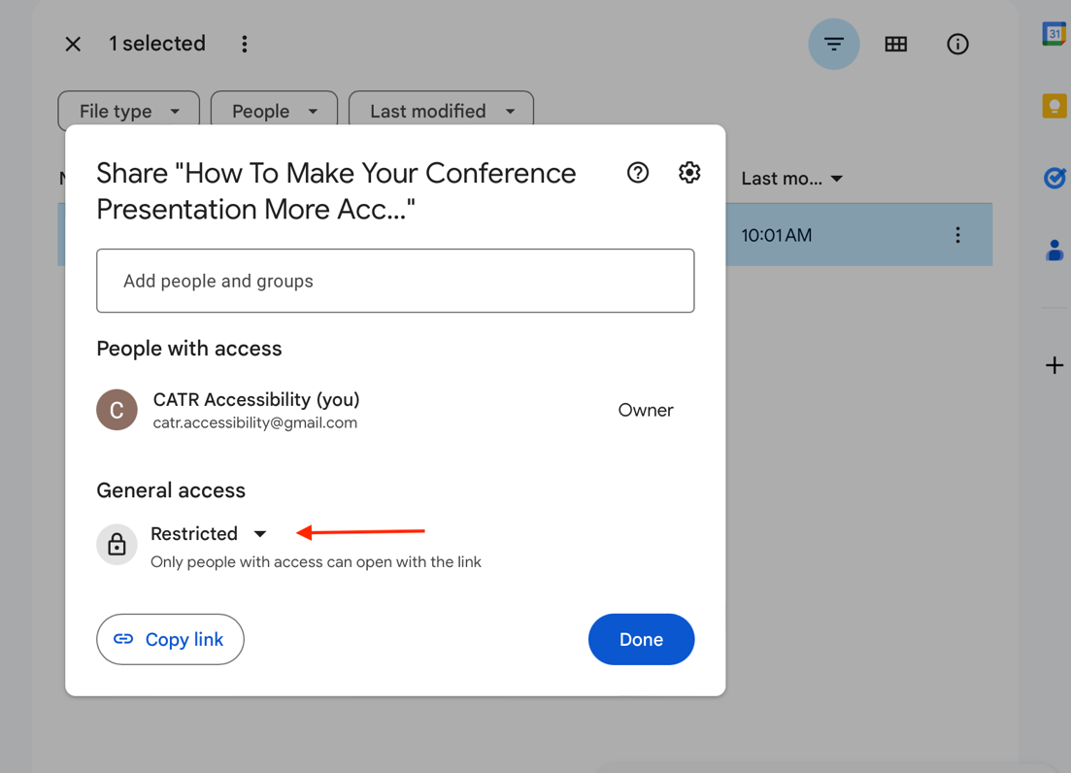

- Under “General access”, click on “Restricted”, which will bring up the following sharing settings:
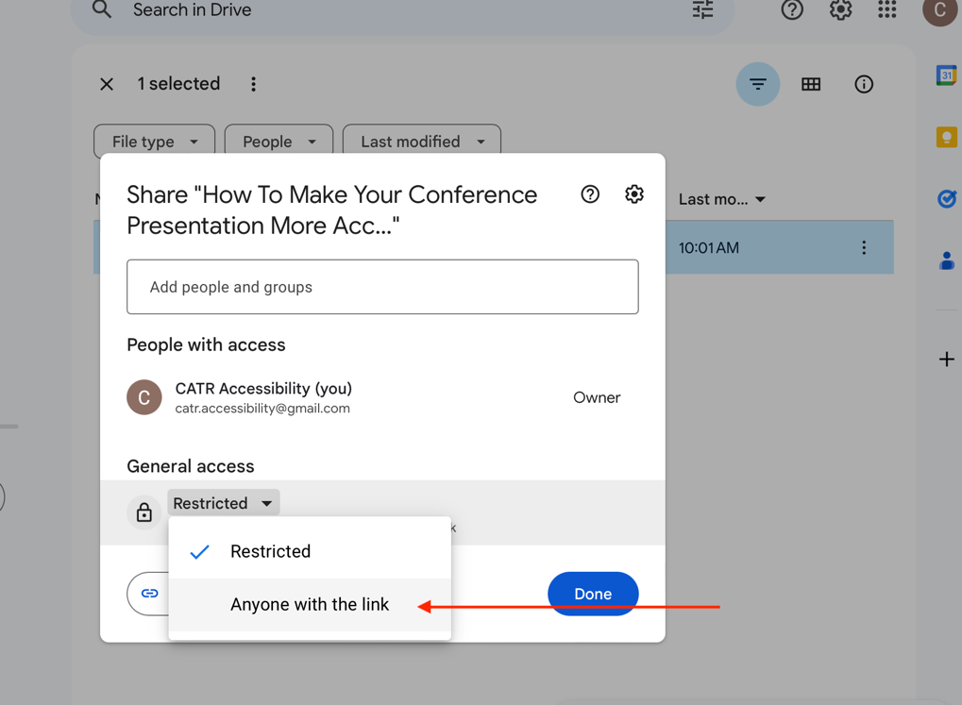

- Click on “Anyone with the link.” This setting enables anyone attending your online session to view your access paper.

- Verify that under “General access”, it says “Viewer.” This setting will prevent others from editing your access document.

- Click on the tool icon (advanced settings button) located in the top right corner of this menu:
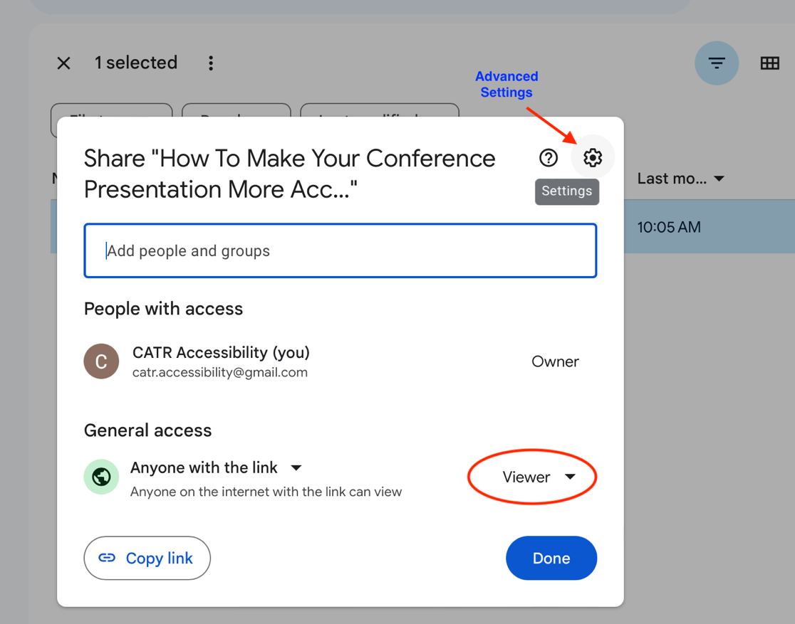

- Uncheck “Viewers and commenters can see the option to download, print, and copy.” This will prevent others from copying and downloading your access paper.

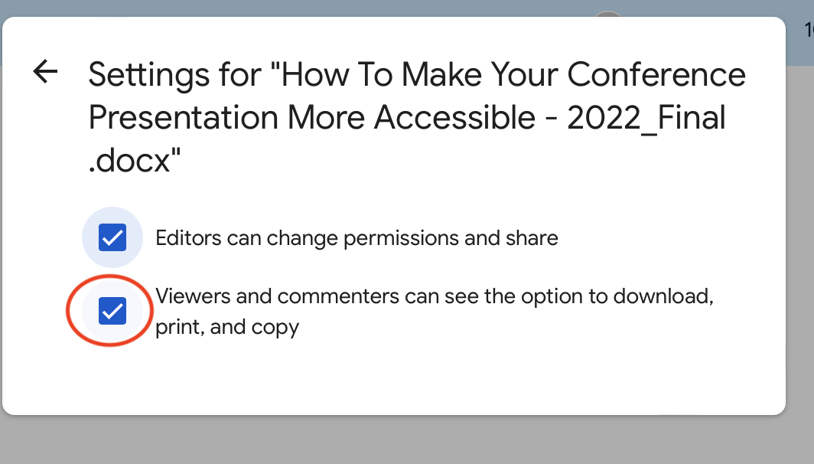

- Return to the sharing settings and click on the “Copy link” button located in the bottom-left corner of the menu.

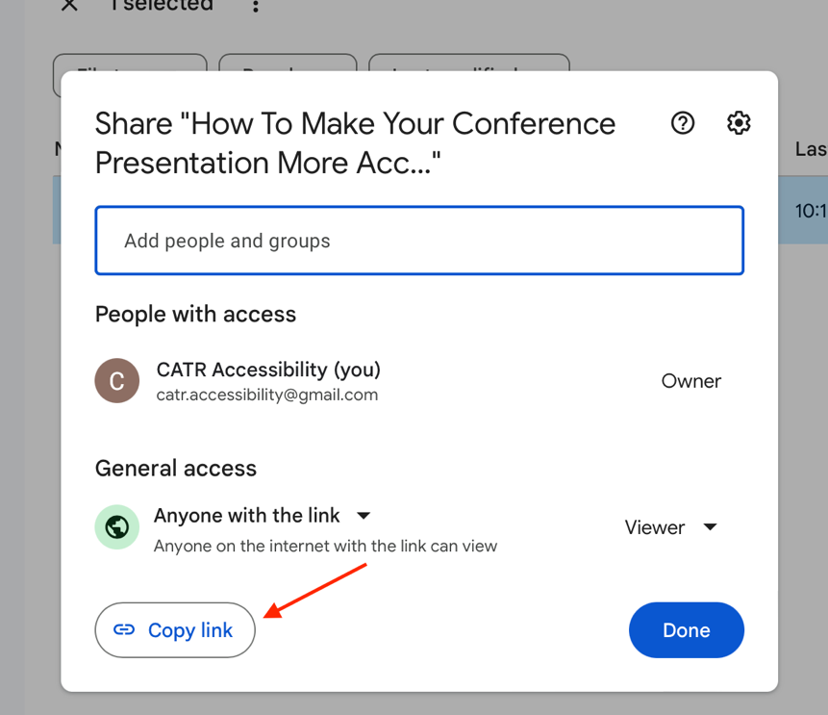

- Finally, paste your access paper link somewhere for safekeeping until your session begins.

- At the start of your presentation, copy + paste your online access paper link into the Zoom chat to share with attendees. OR you can also email your link to your session moderator and ask if they can post the link for you at the top of your presentation.

**If you would like to remove your access paper after your session is complete, click on the 3 vertical dots (more actions button) and click “Remove”:
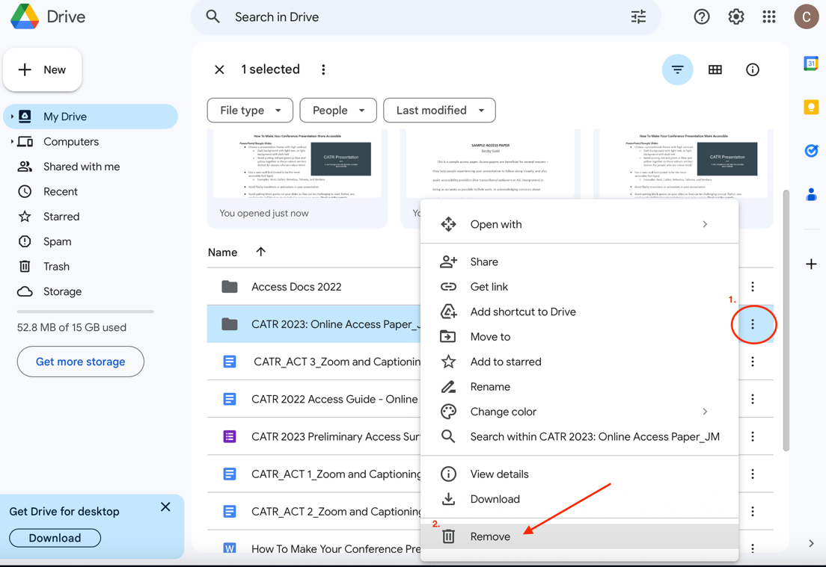

Option 2

- Start by opening Google Drive in your Google apps:

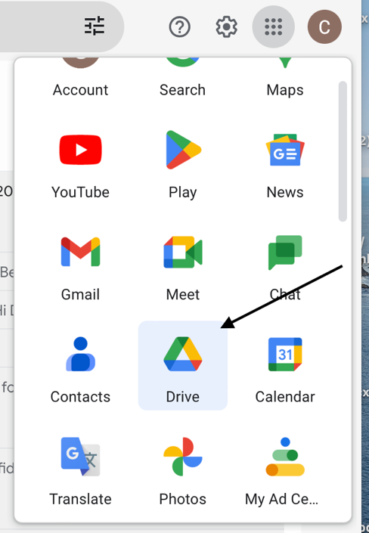

- Once you’ve opened Google Drive, go the top-left menu bar, and click the “+ NEW” button.

- This will bring up a drop-down menu that looks like this. Click on “File Upload.”

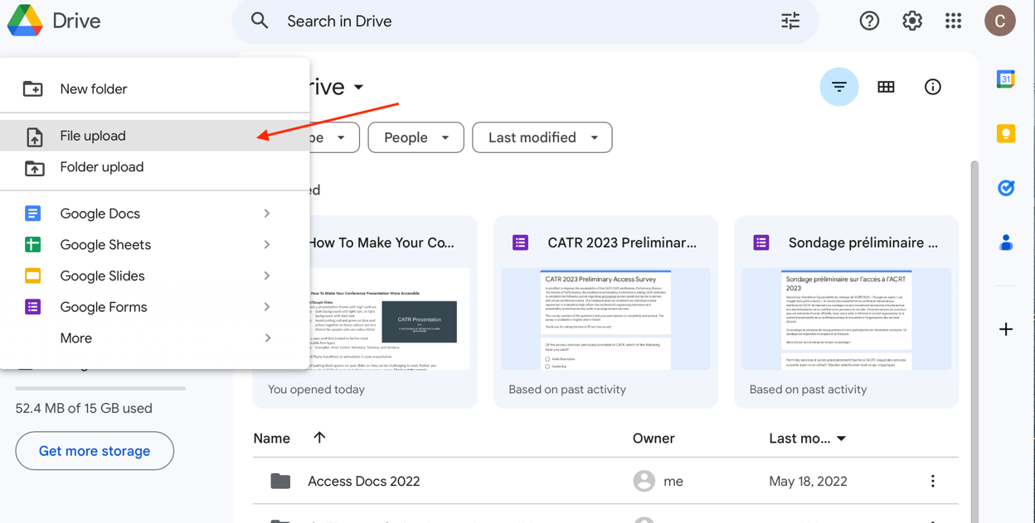

- Select your access paper from the list of documents on your computer and click “Upload.”
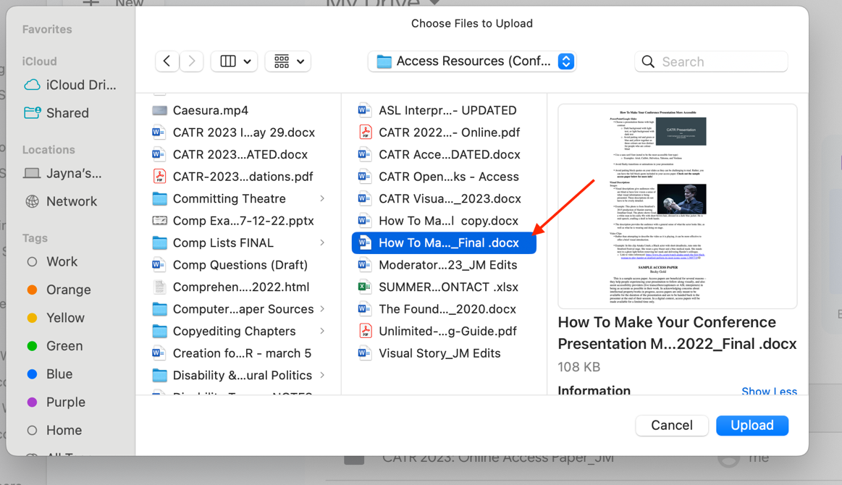

- Once your access paper has finished uploading, double-click to open and verify that your access paper is:
- Using a sans serif font (Arial, Calibri, Helvetica, Tahoma, Verdana)
- Using font size 14-16
- And that the spacing + overall layout of your document has remained the same (sometimes when transferring from an outside app or software like Word to Google docs, the spacing/layout can shift slightly).

- Once you’ve checked your layout, click on the 3 vertical dots (more actions button) located on the right side of your file. This will bring up a new drop-down menu. Click on “Share.”
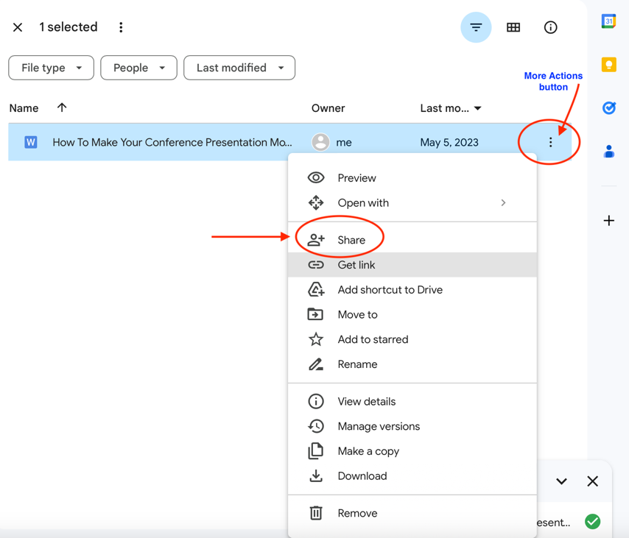

- This will bring up the following menu:
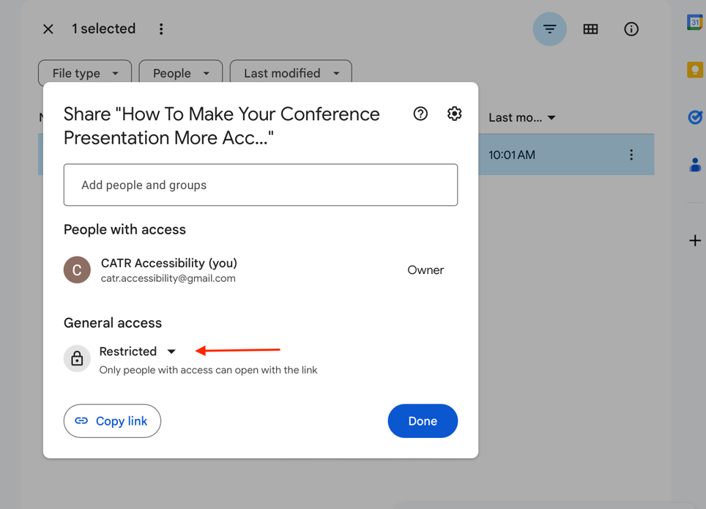

- Under “General access”, click on “Restricted”, which will bring up the following sharing settings:
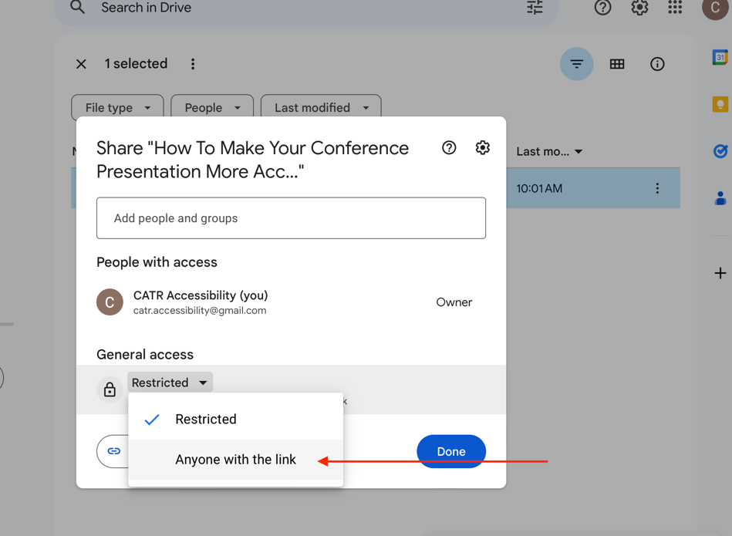

- Click on “Anyone with the link.” This setting enables anyone attending your online session to view your access paper.

- Verify that under “General access”, it says “Viewer.” This setting will prevent others from editing your access document.

- Click on the tool icon (advanced settings button) located in the top right corner of this menu:
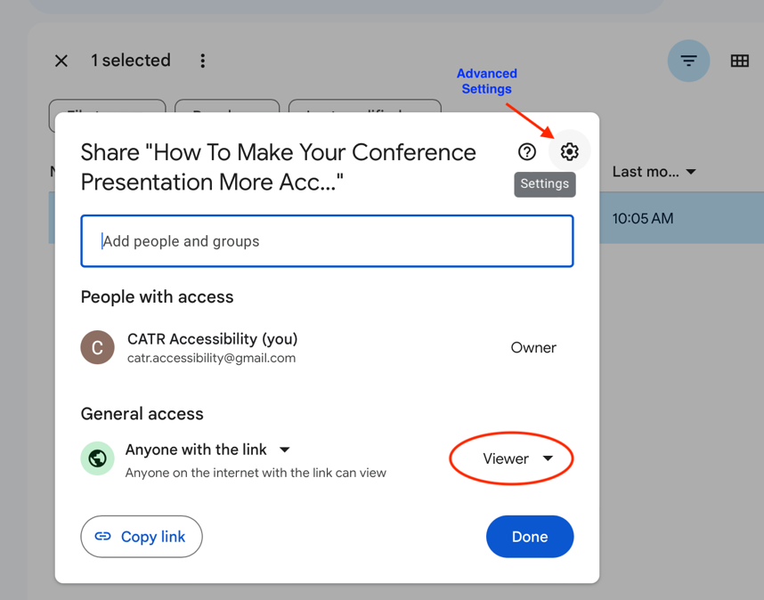

- Uncheck “Viewers and commenters can see the option to download, print, and copy.” This will prevent others from copying and downloading your access paper.

- Return to the sharing settings and click on the “Copy link” button located in the bottom-left corner of the menu.
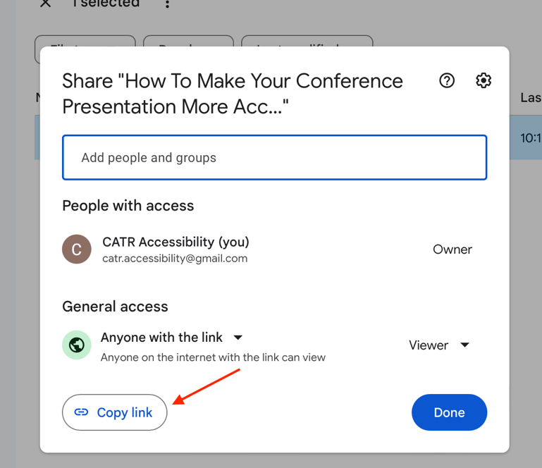

- Finally, paste your link somewhere for safekeeping until your session begins.

- At the start of your presentation, copy + paste your online access paper link into the Zoom chat to share with attendees. OR you can also email your link to your session moderator and ask if they can post the link for you at the top of your presentation.

**If you would like to remove your access paper after your session is complete, click on the 3 vertical dots (more actions button) and click “Remove”:

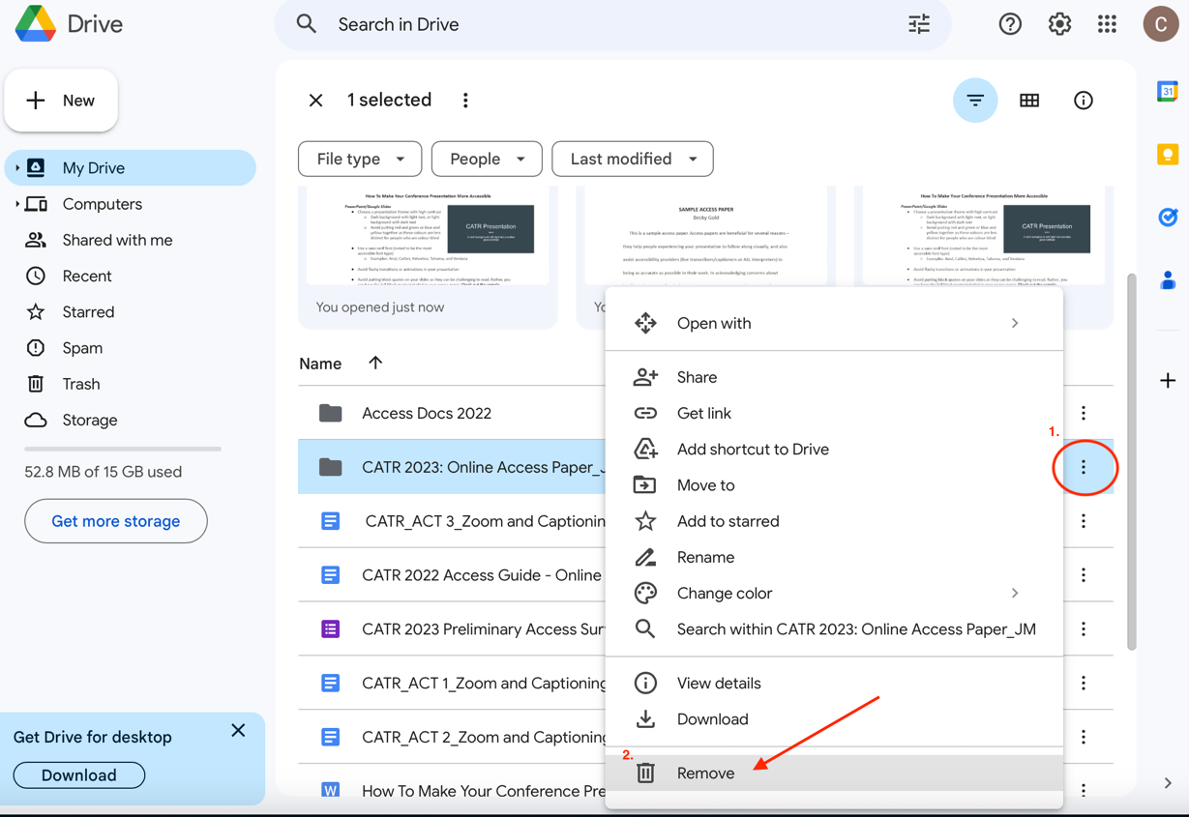

Option 3

- Select and copy your access paper text. Open Google docs (https://docs.google.com/document/u/9/) and under “Start a new document”, double-click “Blank.”
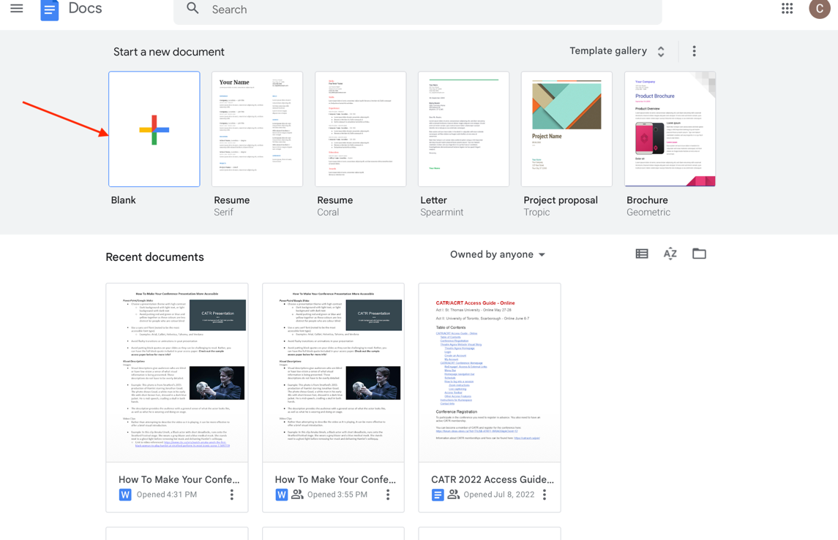

- Paste the text from your access paper into your new blank Google doc.

- Make sure to review your copied access paper and verify that you are:
- Using a sans serif font (Arial, Calibri, Helvetica, Tahoma, Verdana)
- Using font size 14-16
- And that the spacing + overall layout of your document has remained the same (sometimes when transferring text from an outside app or software like Word to Google docs, the spacing/layout can shift slightly).

- Make sure to give your access paper a name:
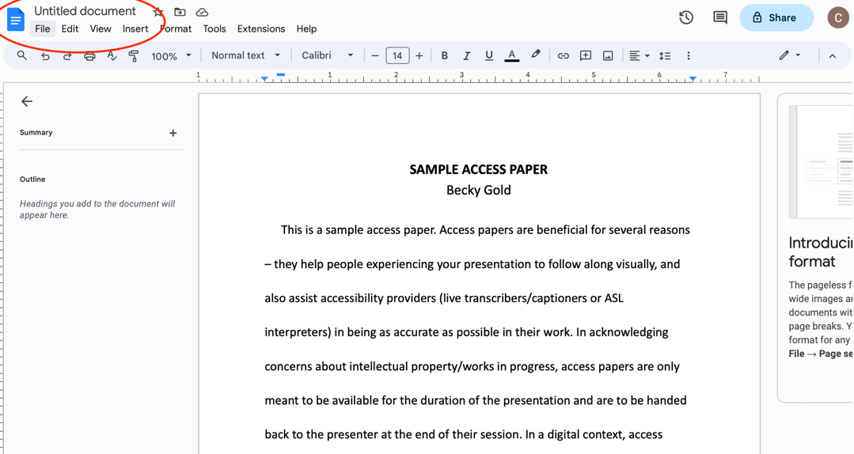

- After naming your access paper, click the “Share” button in the top-right corner:

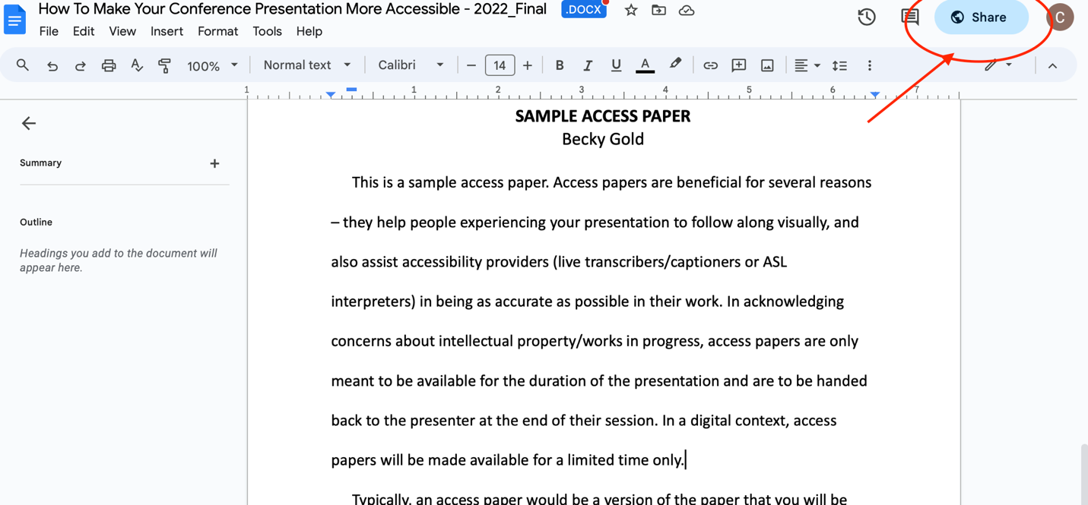

- This will bring up the following menu:
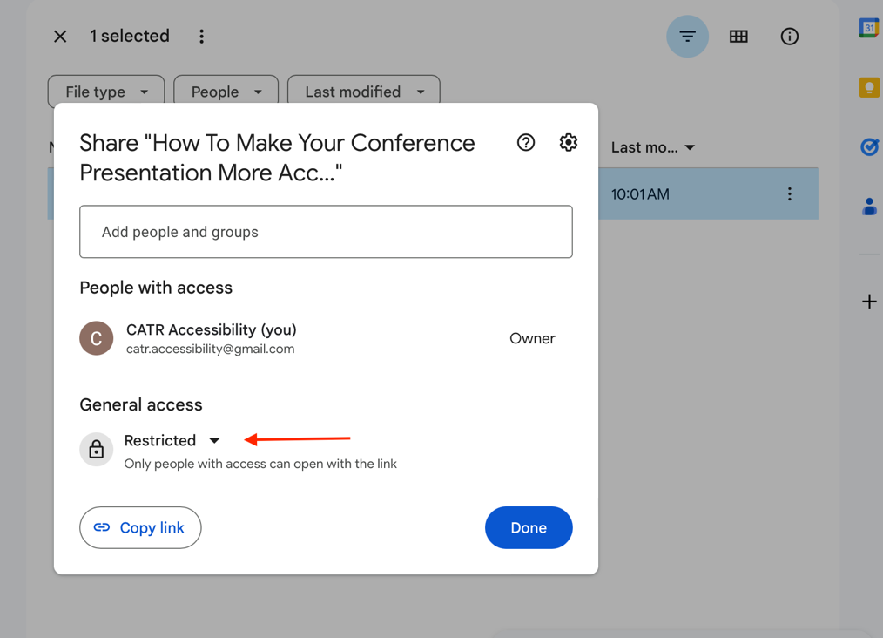

- Under “General access”, click on “Restricted”, which will bring up the following sharing settings:

- Click on “Anyone with the link.” This setting enables anyone attending your online session to view your access paper.

- Verify that under “General access”, it says “Viewer.” This setting will prevent others from editing your access document.

- Click on the tool icon (advanced settings button) located in the top right corner of this menu:

- Uncheck “Viewers and commenters can see the option to download, print, and copy.” This will prevent others from downloading and copying your access paper.

- Return to the sharing settings and click on the “Copy link” button located in the bottom-left corner of the menu:

- Finally, paste your link somewhere for safekeeping until your session begins:

- At the start of your presentation, copy + paste your online access paper link into the Zoom chat to share with attendees. OR you can also email your link to your session moderator and ask if they can post the link for you at the top of your presentation.

**If you would like to remove your access paper after your session is complete, click on the 3 vertical dots (more actions button) and click “Remove”:
